Aug 22 2018

General Changes to scripts:

3 basepaths instead of 1

Importing regions into new EV files

Change to template:

Put Sv 38 raw pings T2 as associated with 38 kHz instead of 120 kHz

Associated Sv raw pings T2 with 38 kHz transducer

Doesn’t look like the euphausiid variables (Euphau 120 kHz_120-38 or CHU export hz120) is successfully pulling out euphausiids:

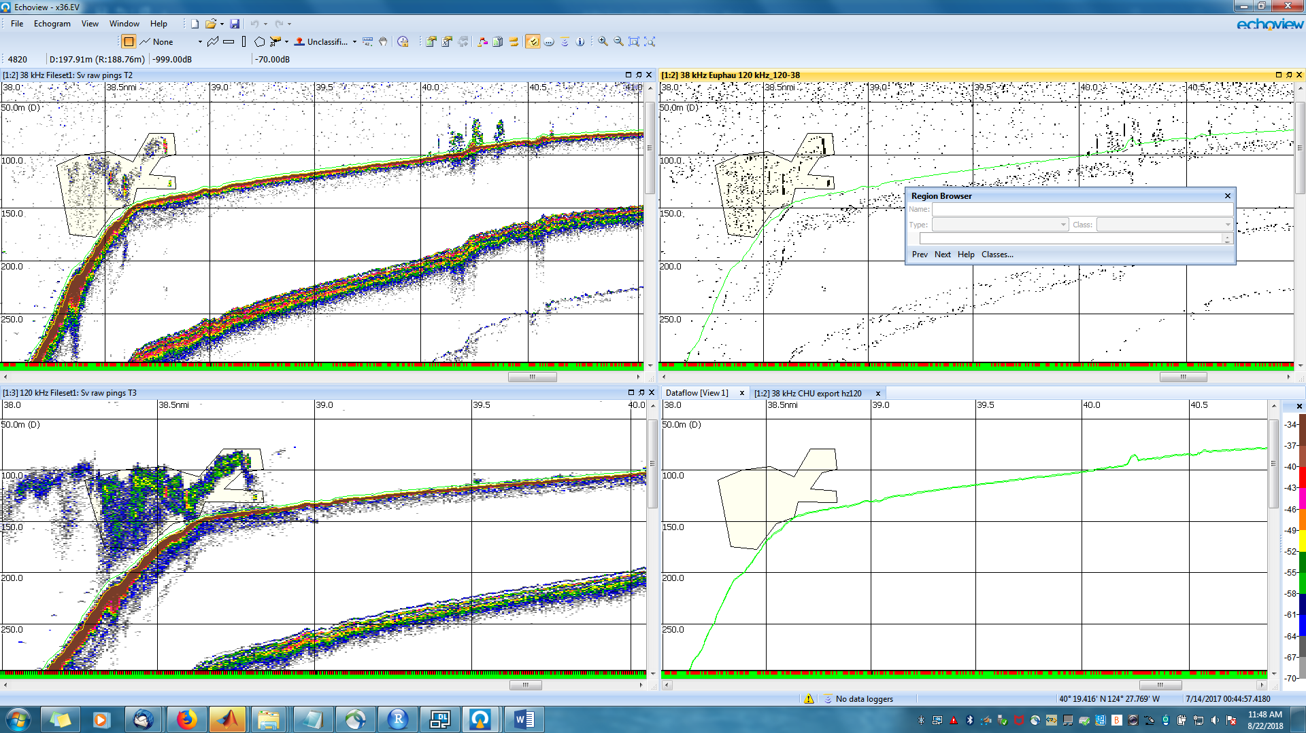

Fig. 1: X36 “plankton” region21

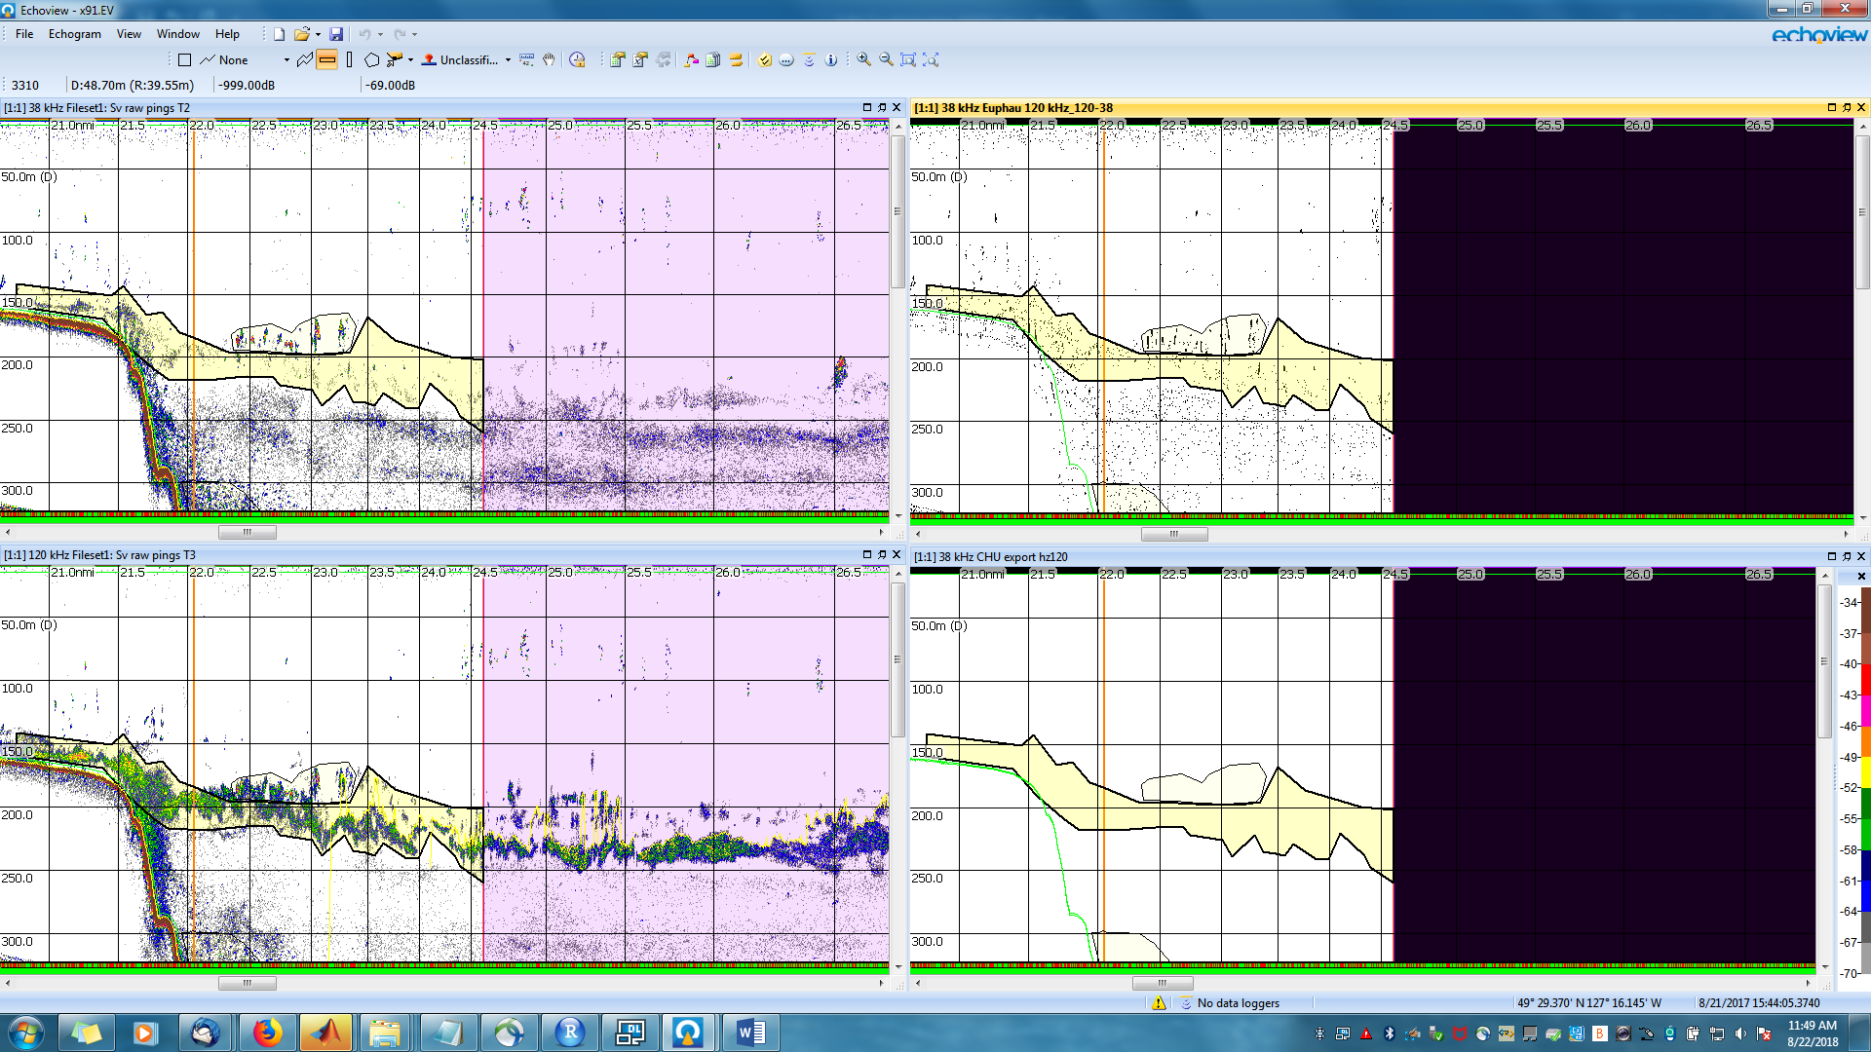

Fig. 2: X91, region 14

Okay, looks like the variable that starts the processed data process for 120 kHz is coming from T2, not T3.

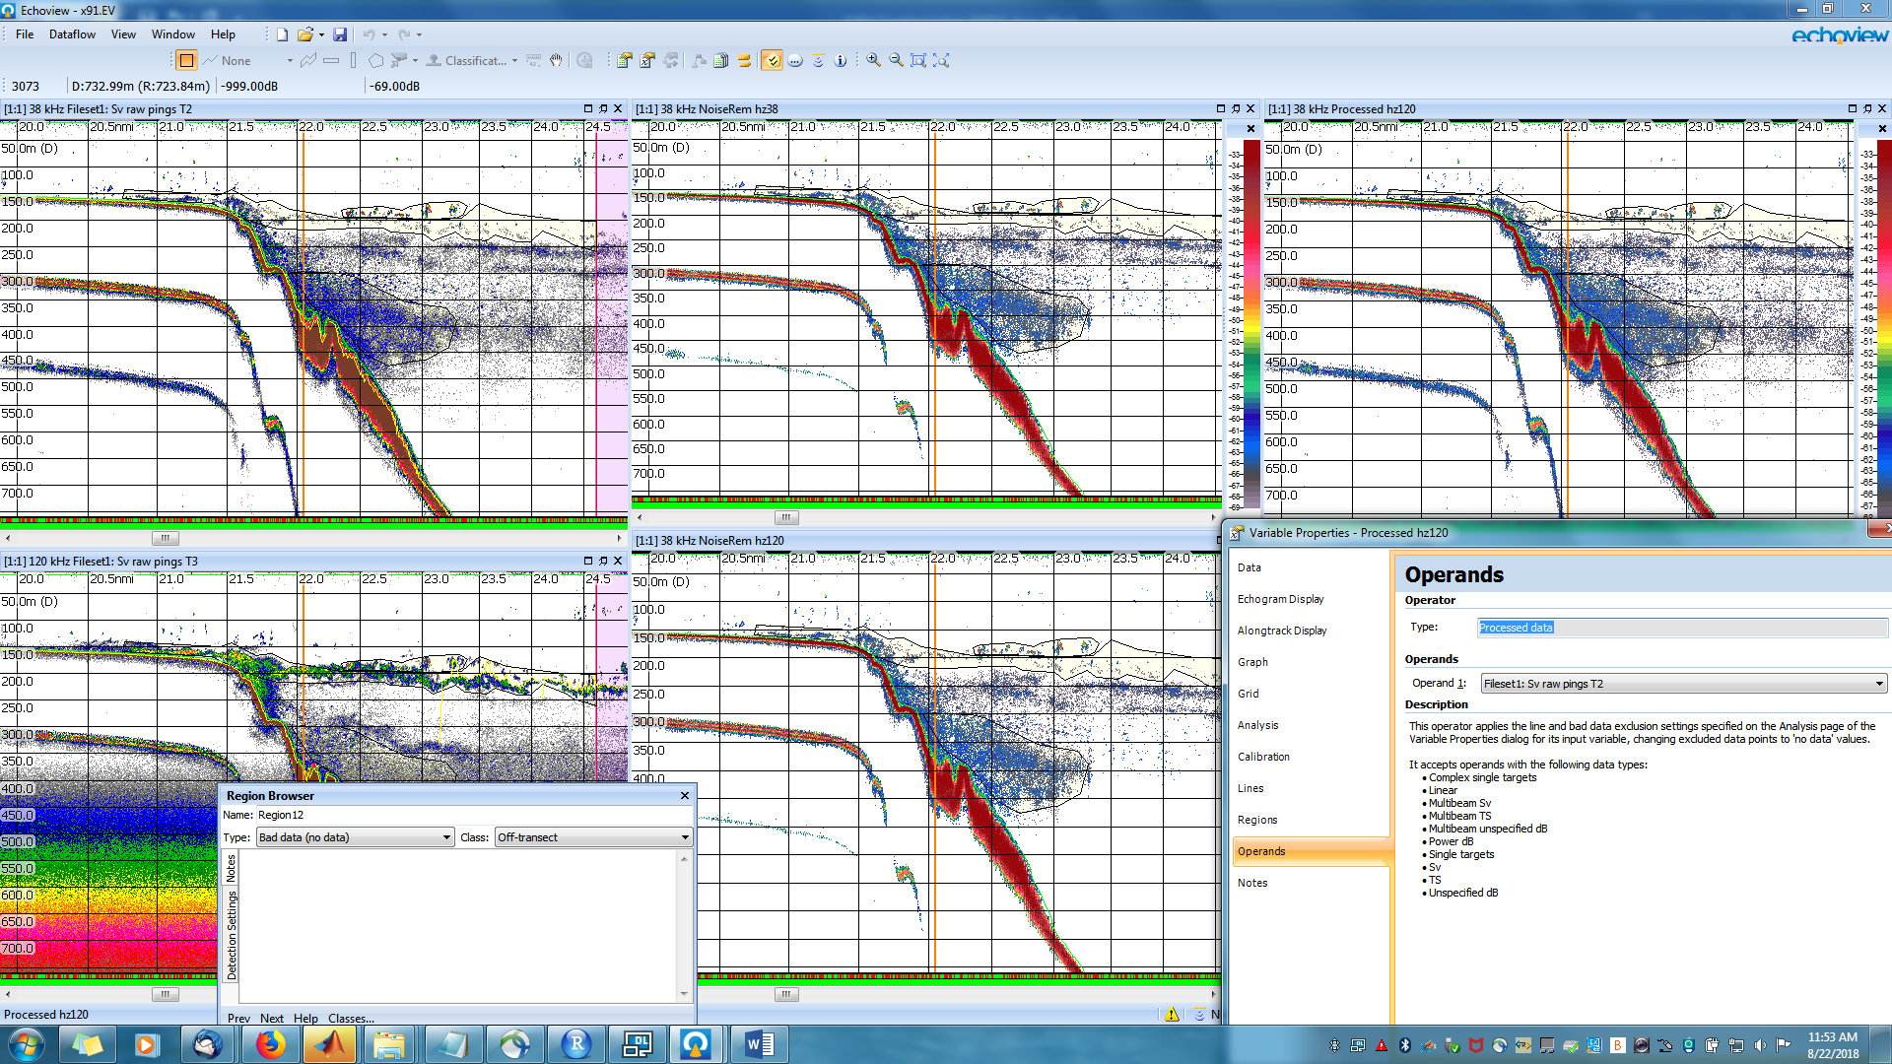

Fig. 3: X91, region 14

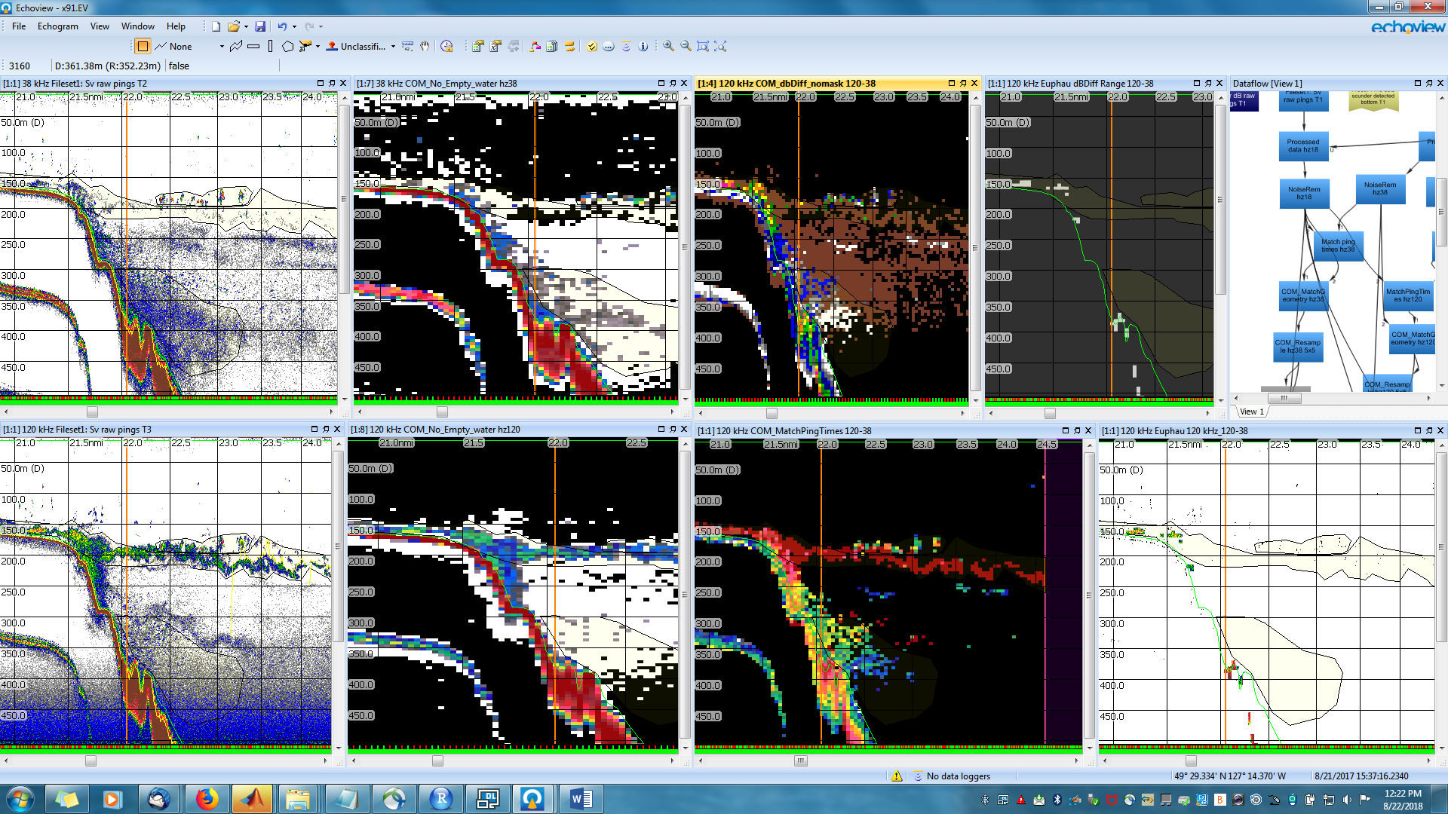

Fig. 4: x91, region 14

However, after fixing that, we still don’t get euphausiid coming out in the euphausiid variable. Looking back through the variable tree, I can see that although it looks like you can see euphausiids coming through as red near the end of the chain, they are actually -999. What looks like is going on is way back at the beginning when the dB difference is done, there is -999 in the 38 kHz Sv, so when the 38kHz is subtracted from the 120 kHz, it gives -999. There is thresholding in the 38 kHz processed data, which gives -999 for less than -70 dB. I don’t know the algorithm well enough to know how to solve the problem – perhaps by changing the threshold, but I don’t know.

Aug 23, 2018

I went through and took out the thresholds for 38 kHz. De Robertis et al seems to state that their requirement was for any frequency to be above -70 (not necessarily all). Taking out the threshold on 38 kHz but not 120 isn’t strict interpretation of what de Robertis did, but it’s a good test. -70 dB thresholds were found in the template both in the 38 kHz processed data (first step) as well as later in the COM_Empty_water hz38. I took out both of those, and now we get euphausiid data coming through.

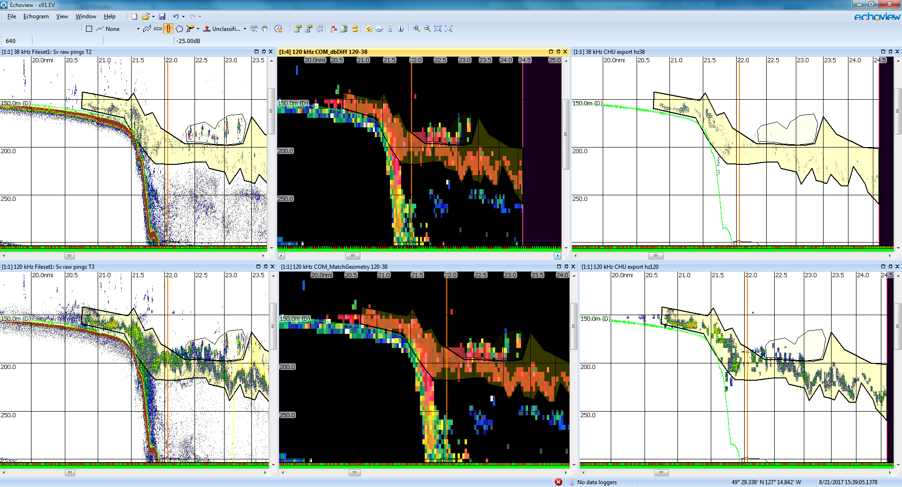

Fig. : x91, region 14